This is the same .avi converted via WinX HD Video Converter Plus
Original (no changes, just a check)

Run through converter, set to .avi; Create DivX format
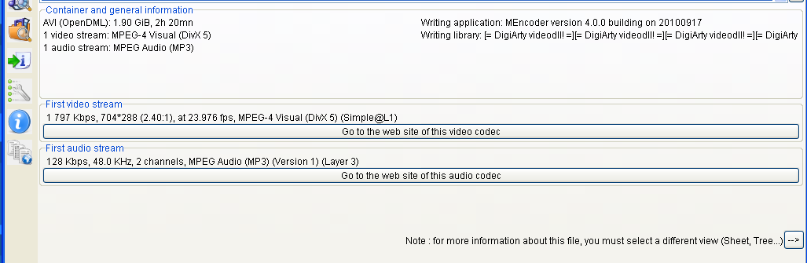

Run through converter, set to .avi; Create XviD format

